## **Lab 23: Android Spinner**

# **Introduction**

A user can slide the thumb back and forth to adjust the progress value in the Android Seek Bar, which is a modified version of the Progress Bar. In our Android device, seek bar can be used for things like brightness and volume control.

**Let’s get Started:**

In this exercise, we will learn how to create Seek Bar in our Android application using Kotlin as our programming language.

**Step 1:** open **activity_main.xml** file from **\res\layout** folder path and write the code like as shown below.

**activity_main.xml**

*<?*xml version="1.0" encoding="utf-8"*?>*<LinearLayout xmlns:android="http://schemas.android.com/apk/res/android"  
 android:orientation="vertical"  
 android:layout_width="match_parent"  
 android:layout_height="match_parent"  
 android:id="@+id/linear_layout"  
 android:background="#C2185B"  
 android:gravity = "center">  
 <TextView  
 android:id="@+id/txtView1"  
 android:layout_width="wrap_content"  
 android:layout_height="wrap_content"  
 android:text="Hello Snapchat!"  
 android:textSize = "20dp" />  
 <TextView  
 android:id="@+id/txtView"  
 android:layout_width="wrap_content"  
 android:layout_height="wrap_content"  
 android:text="Select Mobile OS:"  
 android:textSize = "20dp" />  
  
 <Spinner  
 android:id="@+id/spinner"  
 android:layout_width="wrap_content"  
 android:layout_height="wrap_content"  
 android:layout_alignBottom="@id/txtView"/>  
  
</LinearLayout>

**Step 2:** Open main [activity](https://www.tutlane.com/tutorial/android/android-activity-lifecycle) file **MainActivity.kt** and write the code like as shown below.

**MainActivity.kt**

**package** com.example.demopluralsightspinner  
  
**import** android.os.Bundle  
**import** android.support.v7.app.AppCompatActivity  
**import** android.view.View  
**import** android.widget.*  
  
**class** MainActivity : AppCompatActivity() {  
 **override fun** onCreate(savedInstanceState: Bundle?) {  
 **super**.onCreate(savedInstanceState)  
 setContentView(R.layout.*activity_main*)  
 *// access the items of the list* **val** languages = *resources*.getStringArray(R.array.*os*)  
 **val** spinner = findViewById<Spinner>(R.id.*spinner*)  
 **if** (spinner != **null**) {  
 **val** adapter = ArrayAdapter(**this**,  
 android.R.layout.*simple_spinner_item*, languages)  
 spinner.*adapter* = adapter  
 spinner.*onItemSelectedListener* = **object** :  
 AdapterView.OnItemSelectedListener {  
 **override fun** onItemSelected(parent: AdapterView<*>,  
 view: View, position: Int, id: Long) {  
 Toast.makeText(**this**@MainActivity,  
 getString(R.string.*selected_item*) + **" "** +  
 **""** + languages[position], Toast.*LENGTH_SHORT*).show()  
 }  
 **override fun** onNothingSelected(parent: AdapterView<*>) {  
 }  
 }  
 }  
 }  
}

**Step 3:** Open main [activity](https://www.tutlane.com/tutorial/android/android-activity-lifecycle) file **string.xml** and write the code like as shown below.

<resources>  
 <string name="app_name">SpinnerInKotlin</string>  
 <string name="selected_item">Selected item:</string>  
 <string-array name="os">  
 <item>Android</item>  
 <item>IoS</item>  
 <item>Windows</item>  
 <item>Blackberry</item>  
 </string-array>  
</resources>

**Step 4: Check Output on Android Emulator and it should look like as given below.**

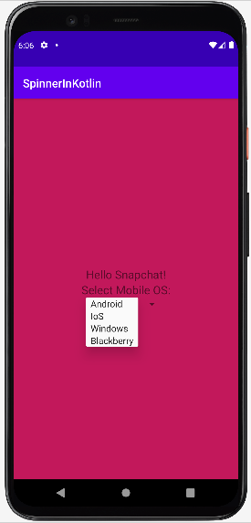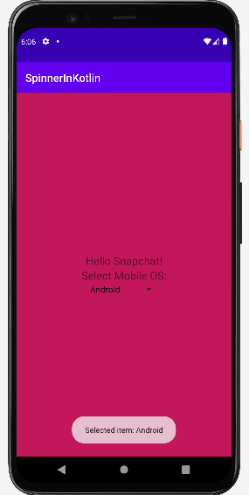

**Voila!!** We have successfully completed this lab.